EXPERIMENT-1

AIM: Demonstration and study about different physical equipment used for networking; NIC (Network Interface Card), types of cable, Fiber Optics

Learning Objective:
At the end of the session you will be able to become familiar with different types of equipment’s and cables used in the networked lab.

What is a Computer Network?
Computer network means an interconnected collection of autonomous computers. Two computes said to be connected if they are able to exchange information. The connection needs to be done via some transmission media such as a coaxial cable, twisted pair cable; fiber optics, microwaves and communication satellite can also be used.

Benefits of Computer network:
- Resource Sharing
- High Reliability
- Saving Money

Network Components
    - Server
Concept of a server is based on one or more personal computers to perform specific tasks for a number of other PCs. The most common function is disk, file and print servers.
A Disk Server provides low-level support and performs basic read/write operation to disk sectors.
A File Sever is a higher-level support mechanism, performing such function as lockout and dynamic allocation of space on

Workstation
A node or stand-alone PC that is connected with network is called Workstation. A workstation is generally a Client.
NIC (Network Interface Card): The network Interface Card (NIC) is the interface between the PC and physical network connection. It is also called as Network Adapter Card. The NIC is responsible for the operation that tasks place in the physical layer of the OSI model. It is only concerned with sending and receiving) 0s and 1s, using the IEEE 802.3 Ethernet standard.

Function of NIC:
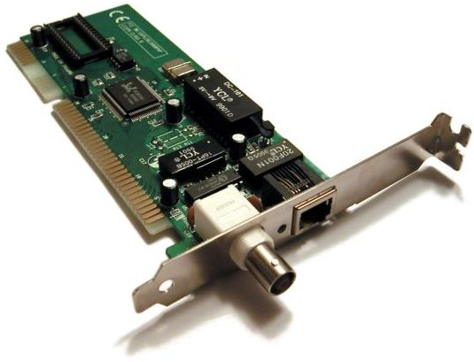
- Data Transfer
- Data Buffering
- Frame Construction
- Media Access Control
- Parallel/Serial Conversion
- Data Encoding/Decoding
- Data Transmission/Reception

Cables
To transmit the data the medium must exist, usually in the form of cables or wireless media. Here are some most commonly used cable types.

Thick Coaxial Cables (thick net) (RG-11)
Thick coaxial cables or thick wire is known as the Ethernet standard RG-11. This cable is mostly used as backbone cable, distributing Ethernet signal throughout a building, an office complex or other large installation. It is used in 10base5 Ethernet standard. The length may be up to 500 meters with a max of five segments connected by repeaters.

Thin coaxial cables (thin net) (RG-58)

RG-58 is typically used for wiring laboratories and offices, or another small group of computers. The maximum length of thin wire Ethernet segment is 185 meters, which is due to the nature of the CSMA/CD method of operation, the cable attenuation, and the speed at which signals propagate inside the coax.
Fig: Thin coaxial cables (thin net) (RG-58)
The length is limited to guarantee that collision is detected when machines that are apart transmit at the same time.

Coaxial Cable Connectors
Coaxial connectors are needed to connect coaxial cable to devices. The most common type of connector used today is the Bayone-Neil-Concelman, in short, BNC connector.
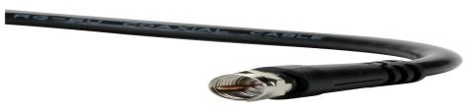

Coaxial Cable Connector
The three popular types of connectors are: the BNC connector, the BNC T connector, and the BNC terminator. The BNC connector is used to connect the end of the cable to a device, such as a TV set. The BNC T connector is used in Ethernet networks to branch out to a connection to a computer or other devices.

The BNC terminator is used at the end of the cable to prevent the reflection of the signal.

Applications
        - Coaxial cable was widely used in analog telephone networks, and later with digital telephone networks.
        - Cable TV networks use coaxial cables (RG-59) at the network boundaries. However, coaxial cable has largely been replaced today with fiber-optic cable due to its higher attenuation.
        - Traditional Ethernet LAN
          - 10Base-2, or thin Ethernet, uses RG-58 coax cable with BNC connectors.
          - 10Base-5, or thick Ethernet, uses RG-11 coax cable with specialized connectors.

Twisted pair cables
Twisted pair is probably the most widely used cabling system in Ethernet in networks. Two copper wires twist around each other to form the twisted pair cable. Depending on category several insulated wire strands can reside in the cable.

Twisted pair is available in two basic types
- Unshielded Twisted Pair (UTP)
- Shielded Twisted Pair (STP)
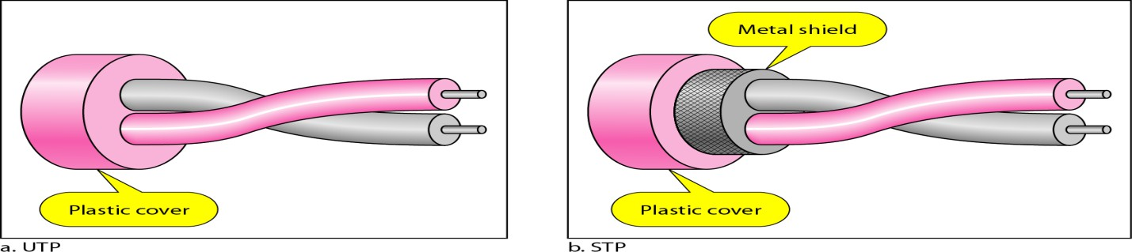
Fig: Twisted pair cables

Unshielded Twisted Pair
Mostly the UTP is used. A twisted pair segment can’t exceed 100 meters. This limitation is the only drawback to twisted pair. Twisted pair is used for 10/100 based Ethernet networks. UTP cables are wired as straight through or crossover cables. Straight through cables typically connect the computer’s networks interface can’t to be a port on the hub.

Category | Descriptor
1 | Used for voice for data.
2 | Contains four twisted pair and a data transmission up to 4 Mbps.  Used for some token ring network.
3 | Contains four twisted pair and a data transmission up to 10 Mbps.  Used for some token ring network.
4 | Contains four twisted pair and a data transmission up to 16 Mbps.  Used for some token ring network.
5 | Contains four twisted pair and a data transmission up to 100 Mbps.  Used for some token ring network.

Category-5 cables can be purchased or crimped as either straight through or crossed. A category-5 cable has 8 thin. Colours coded wires inside that run from one end of the cable to the other. Ethernet networks for communication use only wires 1, 2, 3 and to be connected in both jacks. Straight through cables are used for connecting to a hub. Crossed cables are used for connecting a hub to another hub (there is an exception: some hubs are a built in uplink port that is crossed internally, which allows you to uplink hubs with a straight cable instead.)
For PC 2 PC Communication without HUB (Cross Cable Connection)

Sl. No. | One Site | Second Site | Pin Configuration
01 | Orange White | Green White | Transmit
02 | Orange | Green | Transmit
03 | Green White | Orange White | Receive
04 | Blue | Blue | Not Use
05 | Blue White | Blue White | Ground
06 | Green | Green | Receive
07 | Brown White | Brown White | DTR
08 | Brown | Brown | DTS
For PC 2 PC Communication with HUB (Simple Cable Connection)

Sl. No. | One Site | Second Site | Pin Configuration
01 | Orange White | Orange White | Transmit
02 | Orange | Green | Transmit
03 | Green White | Orange White | Receive
04 | Blue | Blue | Not Use
05 | Blue White | Blue White | Ground
06 | Green | Green | Receive
07 | Brown White | Brown White | DTR
08 | Brown | Brown | DTS
For One Cable in Two PC Communication through HUB (Simple Cable Connection)
First Connection

Sl. No. | One Site | Second Site | Pin Configuration
01 | Orange White | Green White | Transmit
02 | Orange | Orange | Transmit
03 | Green White | Green White | Receive
04 | Green | Green | Receive

Second Connection:

Sl. No. | One Site | Second Site | Pin Configuration
01 | Blue | Green White | Transmit
02 | Blue White | Orange | Transmit
03 | Brown White e | Green White | Receive
04 | Brown | Green | Receive

Shielded Twisted Pair It is 150Ω cable containing additional shielding that protects signals against electromagnetic Interference (EMI) produced by electric motors power lines etc. It is primarily used in Token Ring Network & where UTP cable would provide insufficient protection against interface.

Unshielded Twisted-Pair Connector
The most common Unshielded Twisted-Pair connector is RJ45. RJ stands for registered jack.
Inside the Ethernet cable, there are 8 color coded wires, with all eight pins used as conductors. These wires are twisted into 4 pairs and each pair has a common
color theme. RJ45 specifies the physical male and female connectors as well as the pin assignments of the wires.
RJ45 uses 8P8C modular connector, which stands for 8 Position 8 Contact. It is a keyed connector which means that the connector can be inserted only in a single way. RJ45 is used almost exclusively to refer to Ethernet-type computer connectors.

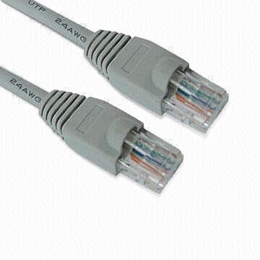
Characteristics of twisted pair cable

Fig: Unshielded Twisted-Pair Connector
- Requires amplifiers every 5-6 km for analog signals
- Requires repeaters every 2-3 km for digital signals
- Attenuation is a strong function of frequency
- Susceptible to interference and noise

Applications

Used in telephone lines provide voice.

DSL lines are also UTP cables.

Fibre Optic.
Fibre Optic relies on pulsed as light to carry information. Two types of plastic or glass with different physical properties are used (the inner core and the outer cladding) to allow a beam of light to reflect off the boundary between the core and cladding.
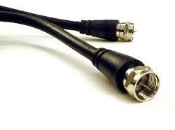
Fiber Optic cable connector

EXPERIMENT-2

Aim: Demonstration and study different internetworking devices in a computer network; Repeater Bridge, Router, Gateway, Hubs, Switches.
Learning Objective: At the end of the session you will be able to be familiar with different types of internetworking devices and their functions.

REPEATER
A Repeater is a purely electrical device that extends maximum distance a LAN cable can span by Amplifying signals passing through it. A Repeater connects two segments and broadcasts packets between them. Since signal loss is a factor in the maximum length of a segment, a Repeater is used to amplify the signal and extend the usable length.
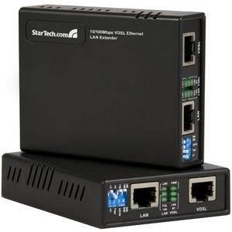
Repeaters

A common Ethernet rule is that no more than four repeaters may be used to join segments together.

BRIDGES
The networks bridge provides an inexpensive and easy way to connect network segments. A bridge provides Amplification function of a repeater plus, ability to select filter packets based on their addresses. When network grows in size, it is often necessary to partition it in to smaller group of nodes to help isolate traffic and improve performance.
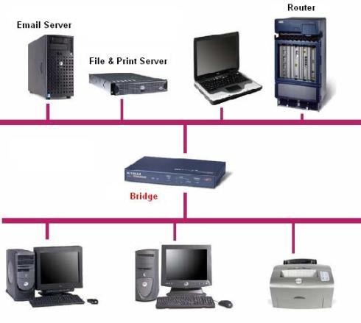
Bridged network

ROUTERS
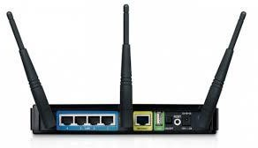
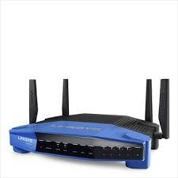
A router is a device that connects two LANs together to form an inter-network. A router is the basic building block of the Internet. Each router connects two or more networks together by providing an interface for an Ethernet network and ring network to which it is connected.
Routers
The router examines each packet of information to detection weather the packet must be translated form on one network to another network performing a function similar to a bridge. Unlike a ridge, a router can connect network that use different technologies, addressing methods, media type, frame format and speeds. A router is a special purpose device designed to interconnect networks. Such that three networks can be connected using two routers.

GATEWAYS
A gateway is node in a network that serves as an entrance to another network. In enterprises, the gateway node often acts as a proxy server and a firewall. The gateway is also associated with both a switch, which provides the actual path for the packet in and out of the gateway. It is also known as a computer system located on earth that switches data signals and voice signals between satellites and terrestrial networks.

HUBS
Hubs are also called concentrators; expand one Ethernet connection into many. For example, a four-port hub connects up to four machines via UTP cables. The hub provides a star connection for the four ports.
A hub is similar to a repeater, expect it broadcasts data received by any port to all other ports on the hub.
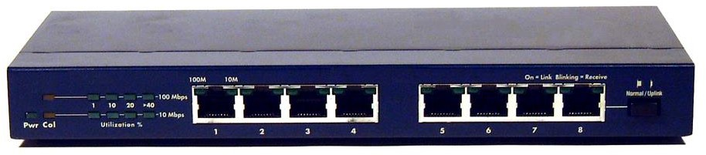

There are three types of HUB passive hub, active hub and intelligent hub. The Passive hubs do not process data signals with only purpose to combine the signal from several networks cables segments. All devices attached to the passive hub receive another packets that pass through the hub .Hub does not clear up or amplify the signals, on the contrary absorbs a small part of the signals that is why the distance between a hub and a computer should not be more than half of the permissible distance between two computers.
The process of cleaning up signal is called “signal regeneration”. The benefits of signals regeneration are:
        - A network is more robust i.e. less sensitive errors.
        - Distance between devices can be increased.
Active hubs cost is considerable more than passive hub (active hub function impart as multi port repeaters). Intelligent hubs are enhanced active hubs the following functions add intelligence to a hub.
Hub Management A hub supports networks network management protocols that enable the hub to send packets to central network console. Theses protocols enable network console to manage or control hub.

Switching hubs
Switching hubs include circuitry that quickly routes signals between ports on the hub. Insured of repeating a packet to all ports on the hub, it repeats a packet only to the port that connects to the destination computer for the packet.

SWITCHES
It is similar to a bridge, with some important enhancement
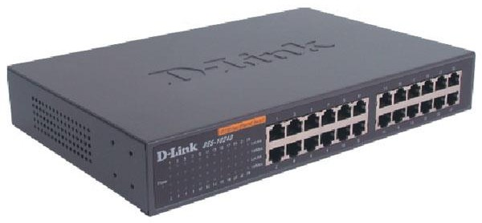
First, as witch may have multiple ports, thus directing packets to several different segments further partitioning and isolating network traffic in as way similar to router.

